CLEVELAND HIKE 2024: TEAM DETAIL SHEET 2 Day EVENT |  |  |  |  |  |  |  |  |  | FOR OFFICIAL USE ONLY
 |  |  |  |  |  |  |  |  |  | TEAM No. =
Please complete in BLOCK CAPITALS and hand in to the START officials. You must complete 1 per team.
* TEAM / COMPANY / ORGANISATION NAME = |  |  |  |  |  |  |  | Start Time =
I confirm that the ages stated below are correct = |  |  |  |  |  |  |  |  | Supporter / Leader | Type of  Team | Standard Male /  Female | Standard 'Mixed' |  | Senior |  | Expedition
* if entering more than one team, please designate 'A', 'B' or 'C' etc.
HIKE COLOUR CODE | FULL NAME & ADDRESS IN BLOCK CAPITALS |  | AGE ON 24/06/23  and D.O.B. | BRIEF DESCRIPTION OF CLOTHES TO BE WORN ON THE WEEKEND, ie COLOURS |  |  |  |  | ANY KNOWN MEDICAL CONDITION OR TREATMENT
 |  |  |  |  |  |  |  |  |  | Kit Check Details |  |  | Quantity |  | Requirement
 |  |  |  |  |  |  |  |  |  | MAPS (sheet 26) West |  |  |  |  | 1 sets minimum
HIKE COLOUR CODE |  |  | AGE ON 24/06/23  and D.O.B. | ( Fair Weather ) |  |  | ( Waterproofs ) |  | ANY KNOWN MEDICAL CONDITION OR TREATMENT | MAPS (sheet 27) East |  |  |  |  | 2 set minimum
 |  |  |  | HAT |  |  | CAGOULE |  |  | Stove, Fuel, Equipment |  |  |  |  | 1 Complete Set
 |  |  |  | SWEATER |  |  | O'TROUSERS |  |  | First Aid Kit |  |  |  |  | 1 LARGE ONE
 |  |  |  | SHIRT |  |  | GAITERS |  |  | Tent |  |  |  |  | 1 per Gender
 | mobile phone = |  |  | TROUSERS |  |  | RUCKSACK |  |  | Survival Bag |  |  |  |  | Per person
 | e-mail (optional) |  |  | other |  |  | other |  |  | Compass |  |  |  |  | Per person
 |  |  |  | SWEATER |  |  | O'TROUSERS |  |  | Watch |  |  |  |  | Per person
 |  |  |  | SHIRT |  |  | GAITERS |  |  | Torch + spares |  |  |  |  | Per person
 | mobile phone = |  |  | TROUSERS |  |  | RUCKSACK |  |  | Rucksack |  |  |  |  | Per person
 | e-mail (optional) |  |  | other |  |  | other |  |  | Whistle |  |  |  |  | Per person
 |  |  |  | HAT |  |  | CAGOULE |  |  | Emergency Food |  |  |  |  | Per person
 |  |  |  | SWEATER |  |  | O'TROUSERS |  |  | Pencil & Paper |  |  |  |  | Per person
 |  |  |  | SHIRT |  |  | GAITERS |  |  | Sleeping bag |  |  |  |  | Per person
 | mobile phone = |  |  | TROUSERS |  |  | RUCKSACK |  |  | Boots/Shoes (with tread) |  |  |  |  | Per person
 | e-mail (optional) |  |  | other |  |  | other |  |  | Clothes |  |  |  |  | Per person
 |  |  |  | HAT |  |  | CAGOULE |  |  | Spare Clothes |  |  |  |  | Per person
 |  |  |  | SWEATER |  |  | O'TROUSERS |  |  | Waterproof set |  |  |  |  | Per person
 |  |  |  | SHIRT |  |  | GAITERS |  |  | WATER min 500ml |  |  |  |  | Per person
 | mobile phone = |  |  | TROUSERS |  |  | RUCKSACK |  |  | Hat & Gloves |  |  |  |  | Per person
 | e-mail (optional) |  |  | other |  |  | other |  |  | COMMENTS |  |  | (*) penalty = 25pts per person
 |  |  |  | HAT |  |  | CAGOULE |  |  |  |  |  | (*) U19 → non competitive
 |  |  |  | SWEATER |  |  | O'TROUSERS
 |  |  |  | SHIRT |  |  | GAITERS |  |  | Kit Checker =
 | mobile phone = |  |  | TROUSERS |  |  | RUCKSACK
 | e-mail (optional) |  |  | other |  |  | other |  |  | committee signature if needed =
Team members carrying a mobile phone ( which is to be used for emergency use only ), please state |  |  |  |  |  |  |  |  |  | committee 'M&C' test signature =
Team member name
 |  |  |  |  |  |  |  |  |  | Equipment Penalties = Total Age Penalties =
Moblie number
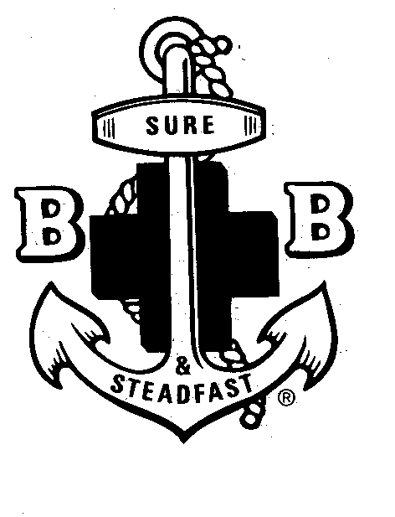

Document C revised April 2024

